

**SwiftBus**

Analysis Document

Team Members: [Youssef Ibrahim, Roaya Youssef, Kareem Salem, Roaa Sameh, Ahmed Mahmoud]

Group - 2 | School Project

2025

**Bus Booking System**

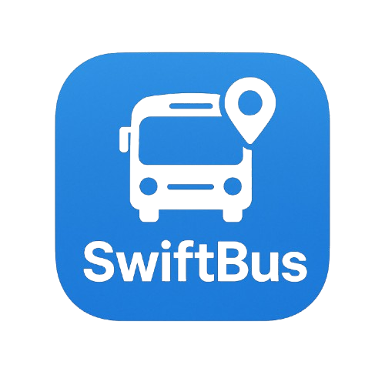

**Table of content:**

**Chapter 1**

1 –introduction

2 –purpose

**3** –scope

4 –objectives

5 –user roles

6 –user stories

7 -usecasediagram

8 –usecasedescription

9 –ActivityDiagram

**Table of content:**

**Chapter 2**

1 - Class Diagram

2 - Object Diagram

3 – Sequence Diagram

4 – UI/UX Design



**Table of content:**

**Chapter 3**

**1. Testing for Application**



**Chapter 1**

**Analysis**

**1 - Introduction**

**------------------------**

This document outlines the system analysis for a Trip Booking and

Management Platform. The platform is designed to simplify the process

of browsing, booking, and managing travel appointments for end users

while providing powerful administrative tools for system administrators

**2 - Purpose**

**----------------------**

The purpose of this system is to streamline the booking process for travel

trips, enabling users to find and book suitable trips easily, manage them

bookings, and provide feedback. At the same time, the platform

empowers administrators to manage trip schedules, handle bookings

efficiently, and maintain high service quality through direct interaction

with user data and feedback.

**3 - Scope**

**-------------------**

The system covers the full lifecycle of trip booking and management,

from user registration and trip search to ticket generation and feedback

collection. It includes functionalities for both end users (travelers) and

administrative staff. Key features include:

* User account creation and login.
* Viewing and filtering trips.
* Submitting and managing booking requests.
* Downloading approved trip tickets in PDF format.
* Providing feedback and rating trips.
* Admin management of trips, users, and destinations.
* Admin approval workflow for booking requests.
* Feedback monitoring and service quality evaluation.

**System Objectives**

**---------------------------------------**

* To provide an intuitive platform for users to book and manage their travel plans.
* To allow administrators full control over trip scheduling, destination management, and user bookings.
* To automate notifications and documentation such as PDF tickets and.
* To support continuous improvement through user feedback and ratings.
* To ensure secure access and protect sensitive booking data

**5 - User Roles**

**----------------------**

#### 🔹 User (Traveler)

* Register and log into the platform.
* Search, filter, and view available trips.
* Submit trip booking requests.
* Track the status of submitted bookings.
* View and manage booking history.
* Download PDF tickets for approved bookings.
* Rate trips and submit feedback.

#### 🔹 Admin (Administration)

* Securely log into the admin dashboard.
* Add, edit, or delete buses
* Add, edit, or delete trips.
* Add, edit, or delete Drivers
* Approve or decline trip booking requests.
* Generate and download PDF tickets for confirmed trips.
* Access and evaluate user feedback and trip ratings.

**6 - User Stories**

**-----------------------**

#### 🔹 As a User:

* I want to create an account or login, so I can use the platform.
* I want to view all available trips, so I can choose a suitable one.
* I want to book a trip by submitting a request.
* I want to track my booking status, so I know if it is approved or declined.
* I want to view my booking history for reference.
* I want to search and filter trips by destination, date, time, to quickly find the right trip.
* I want to download a PDF ticket after my booking is approved, so I can use it for travel.
* I want to give feedback and rate trips, so I can share my experience with others.

#### 🔹 As an Admin:

* I want to login securely, so only authorized staff can access admin tools.
* I want to add, edit, and delete trip appointments, so I can manage the schedule.
* I want to view all Drivers , add , edit , delete.
* I want to see all trip booking requests from users.
* I want to approve or decline trip requests based on seat availability or policies.
* I want to generate and download PDF tickets for confirmed bookings.
* I want to see user ratings and feedback to evaluate service quality and improve it.

**7 – Use Case Diagram**

**---------------------------------**

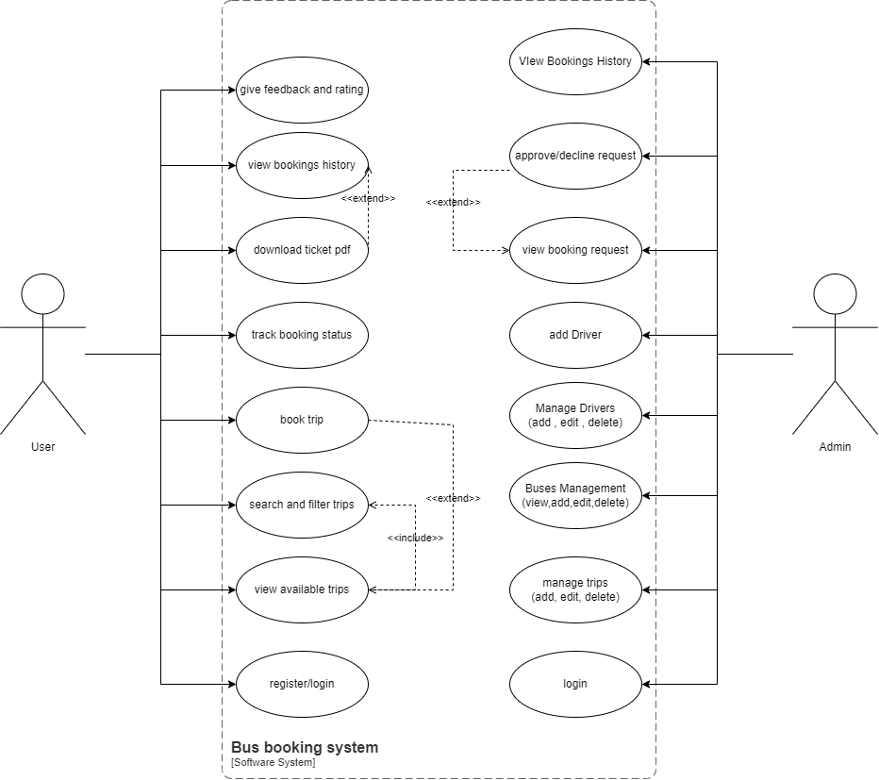

**8 – Use Case Description**

**-------------------------------------**

* register/login

|  |  |
| --- | --- |
| Use case name | register/login |
| Use case description | Allows a user or admin to access the platform by creating an account or logging in. |
| actors | users/admin |
| Preconditions | User or Admin must have account credentials. |
| Postconditions | User/Admin is authenticated and redirected to their dashboard. |
| Main Flow | 1. Open the login or registration page.  2.enter credentials or register new account.  3.system verify credentials  4.redirect to dashboard if successful. |
| Exception flow | Invalid credentials, server errors, or duplicate registration. |

* View Available Trips

|  |  |
| --- | --- |
| Use Case Name | View Available Trips |
| Description | Users can browse the list of trips available for booking. |
| Actors | User |
| Preconditions | User is logged in. |
| Postconditions | List of trips displayed to the user. |
| Main flow | 1. User selects "View Trips".  2.system fetches and displays available trips. |
| Exception Flow | Network issues or no trips available. |

* Search and Filtering Trips

|  |  |
| --- | --- |
| Use Case Name | Search & Filter Trips |
| Description | Allows users to search or filter trips based on criteria. |
| Actors | User |
| Preconditions | User is logged in. |
| Postconditions | Display of filtered search results. |
| Main flow | 1. User inputs destination, date, or time.  2.system filter trips  3.results are shown |
| Exception Flow | No trips match the criteria, or input is invalid. |

* Book Trips

|  |  |
| --- | --- |
| Use Case Name | Book Trip |
| Description | Allows users to book a trip from the list. |
| Actors | User |
| Preconditions | User is logged in. Trips are available. |
| Postconditions | Booking request submitted. Status set to pending. |
| Main Flow | 1. User selects a trip.  2.click “book trip”.  3.system save booking as pending. |
| Exception Flow | No seats available, trip already full, or server error during booking. |

* Track Booking Status

|  |  |
| --- | --- |
| Use Case Name | Track Booking Status |
| Description | Allows users to see if their booking was approved or declined. |
| Actors | User |
| Preconditions | User has made a booking. |
| Postconditions | Display of booking status. |
| Main Flow | 1. User opens booking status page.  2.system shows current status. |
| Exception Flow | Booking not found or server error. |

* Download Tickets PDF

|  |  |
| --- | --- |
| Use Case Name | Download Ticket |
| Description | Users can download a PDF ticket after approval. |
| Actors | User |
| Preconditions | Booking is approved. |
| Postconditions | Ticket PDF downloaded. |
| Main flow | 1. Booking is approved.  2.user click” download ticket”.  3.PDF is generated and downloaded. |
| Exception Flow | Booking not approved, ticket generation failed, or download error. |

* View Booking History

|  |  |
| --- | --- |
| Use Case Name | View Booking History |
| Description | Users can view the history of all bookings. |
| Actors | User |
| Preconditions | User is logged in. |
| Postconditions | Display of all previous bookings. |
| Main Flow | 1. User navigates to booking history.  2.system fetches and shows past booking. |
| Exception Flow | No booking history found or data retrieval error. |

* Give Feedback and Rating

|  |  |
| --- | --- |
| Use Case Name | Give Feedback & Rating |
| Description | User gives feedback or rates a trip. |
| Actors | User |
| Preconditions | User has completed a trip. |
| Postconditions | Feedback is saved and visible to admin. |
| Main flow | 1. User navigates to feedback page.  2.enter rating and comments.  3.system saves feedback. |
| Exception Flow | Invalid input or feedback submission failed. |

* Manage Trips

|  |  |
| --- | --- |
| Use Case Name | Manage Trips |
| Description | Admin can add, edit, or delete trip appointments. |
| Actors | Admin |
| Preconditions | Admin is logged in. |
| Postconditions | Trip data updated. |
| Main flow | 1. Admin opens trip management panel.  2.add/edit/delete trips.  3.system update the trip. |
| Exception Flow | Database error or invalid data entered. |

* View and process booking request

|  |  |
| --- | --- |
| Use Case Name | View & Process Booking Requests |
| Description | Admin views booking requests and approves/declines them. |
| Actors | Admin |
| Preconditions | User has submitted a booking. |
| Postconditions | Booking status updated. |
| Main Flow | 1. Admin opens booking requests.  2.reviews and takes actions.  3.status is updated accordingly. |
| Exception Flow | Booking not found, or status update fails. |

* Generate PDF Ticket

|  |  |
| --- | --- |
| Use Case Name | Generate PDF Tickets |
| Description | Admin generates PDF ticket for approved booking. |
| Actors | Admin |
| Preconditions | Booking is approved. |
| Postconditions | PDF ticket is generated. |
| Main Flow | 1. Admin opens booking.  2.click “generate ticket”.  3.PDF is created. |
| Exception Flow | PDF generation fails or file download error. |

* View Feedback and Ratings

|  |  |
| --- | --- |
| Use Case Name | View Feedback & Ratings |
| Description | Admin reviews feedback left by users. |
| Actors | Admin |
| Preconditions | User has submitted feedback. |
| Postconditions | Admin can see all feedback. |
| Main Flow | 1. Admin navigates to feedback panel.  2.views user's ratings and comments. |
| Exception Flow | No feedback submitted or data fetch failure. |

**9 – Activity Diagram**

**------------------------------**

User Reservation Scenario

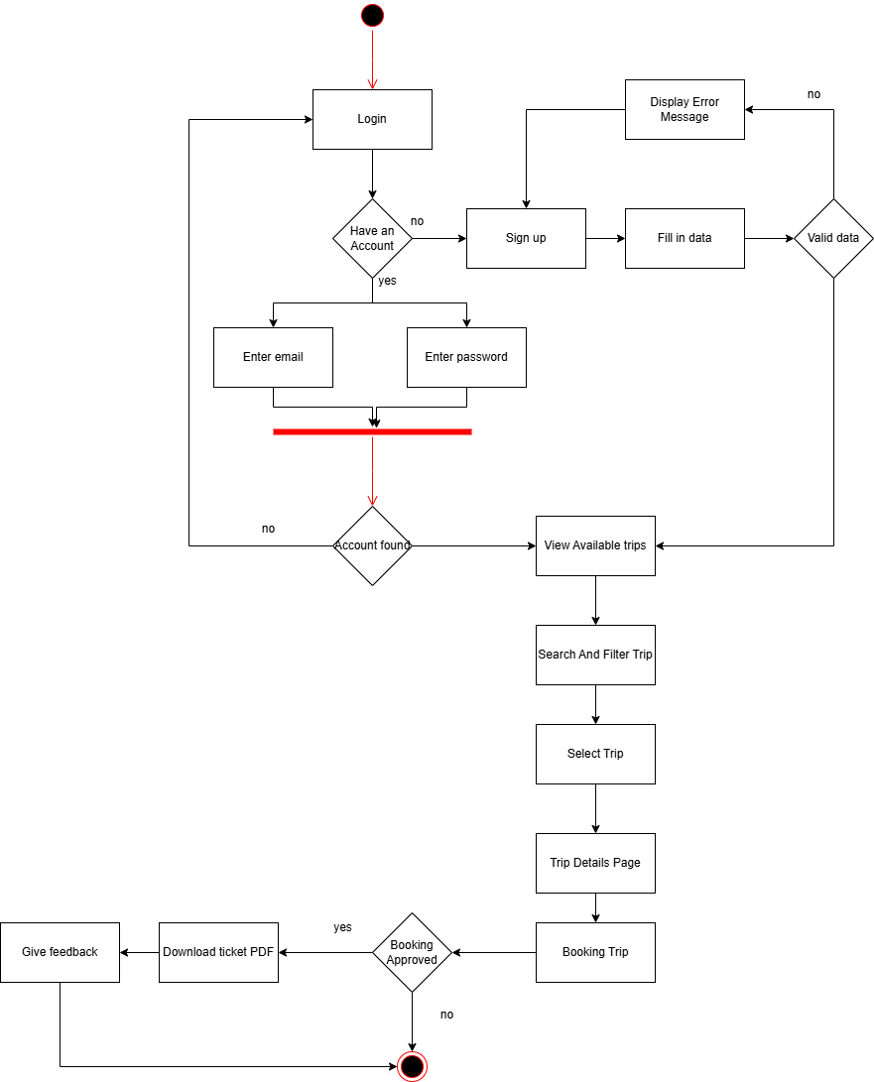

User Reservations View

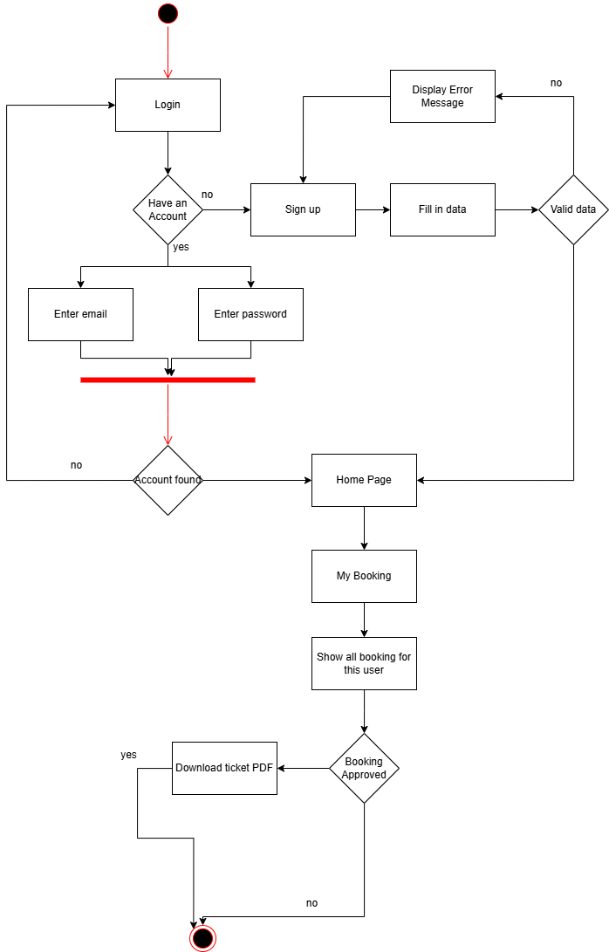

Admin Scenario (Add New Bus)

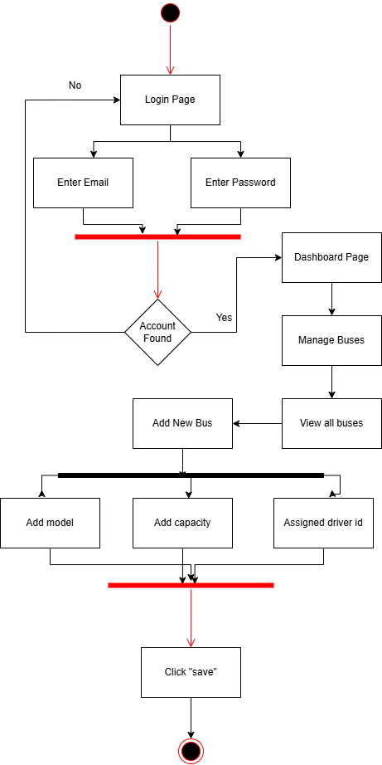

Admin Scenario(Add New Driver)

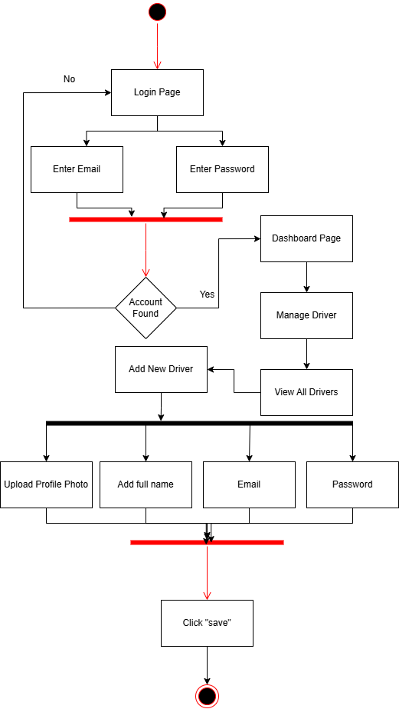

Admin Scenario(Add New Trip)

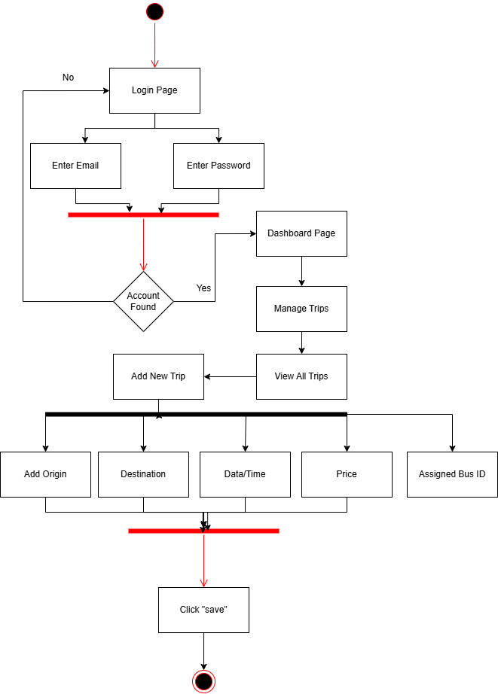

Admin Scenario(Manage Booking)

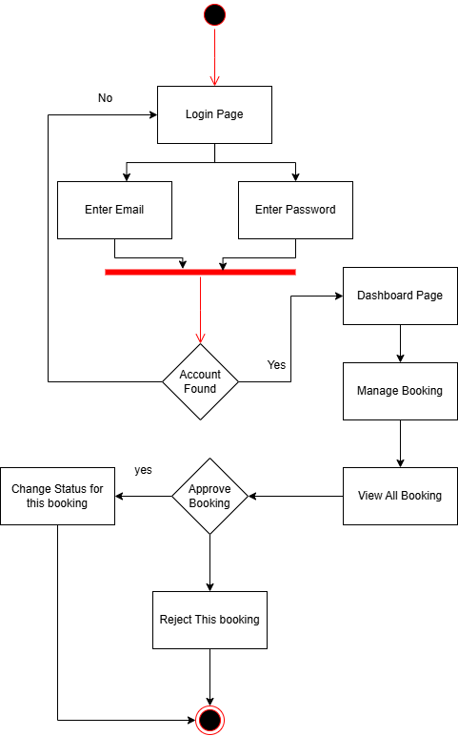

**Chapter 2**

**Design**

**1 – Class Diagram** 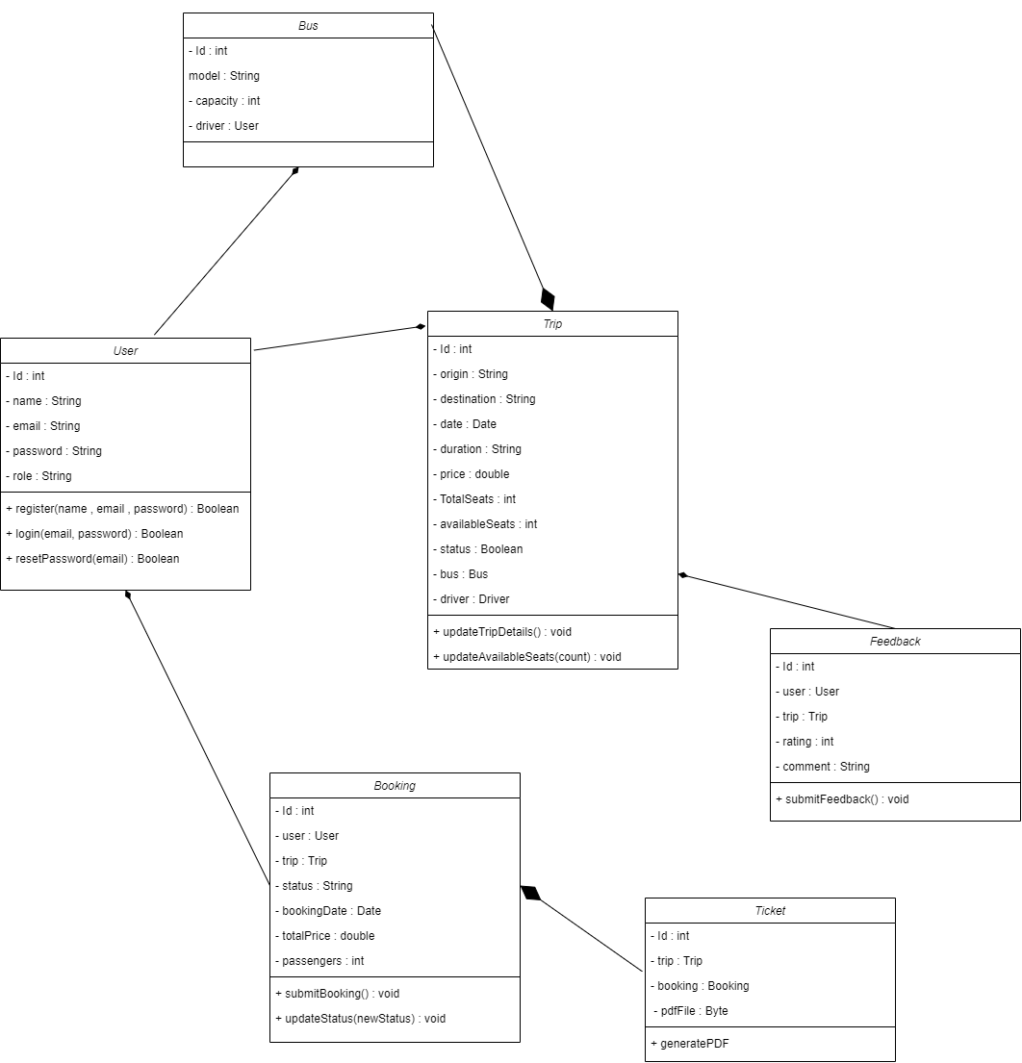

**2 - Object Diagram**

**----------------------------------**

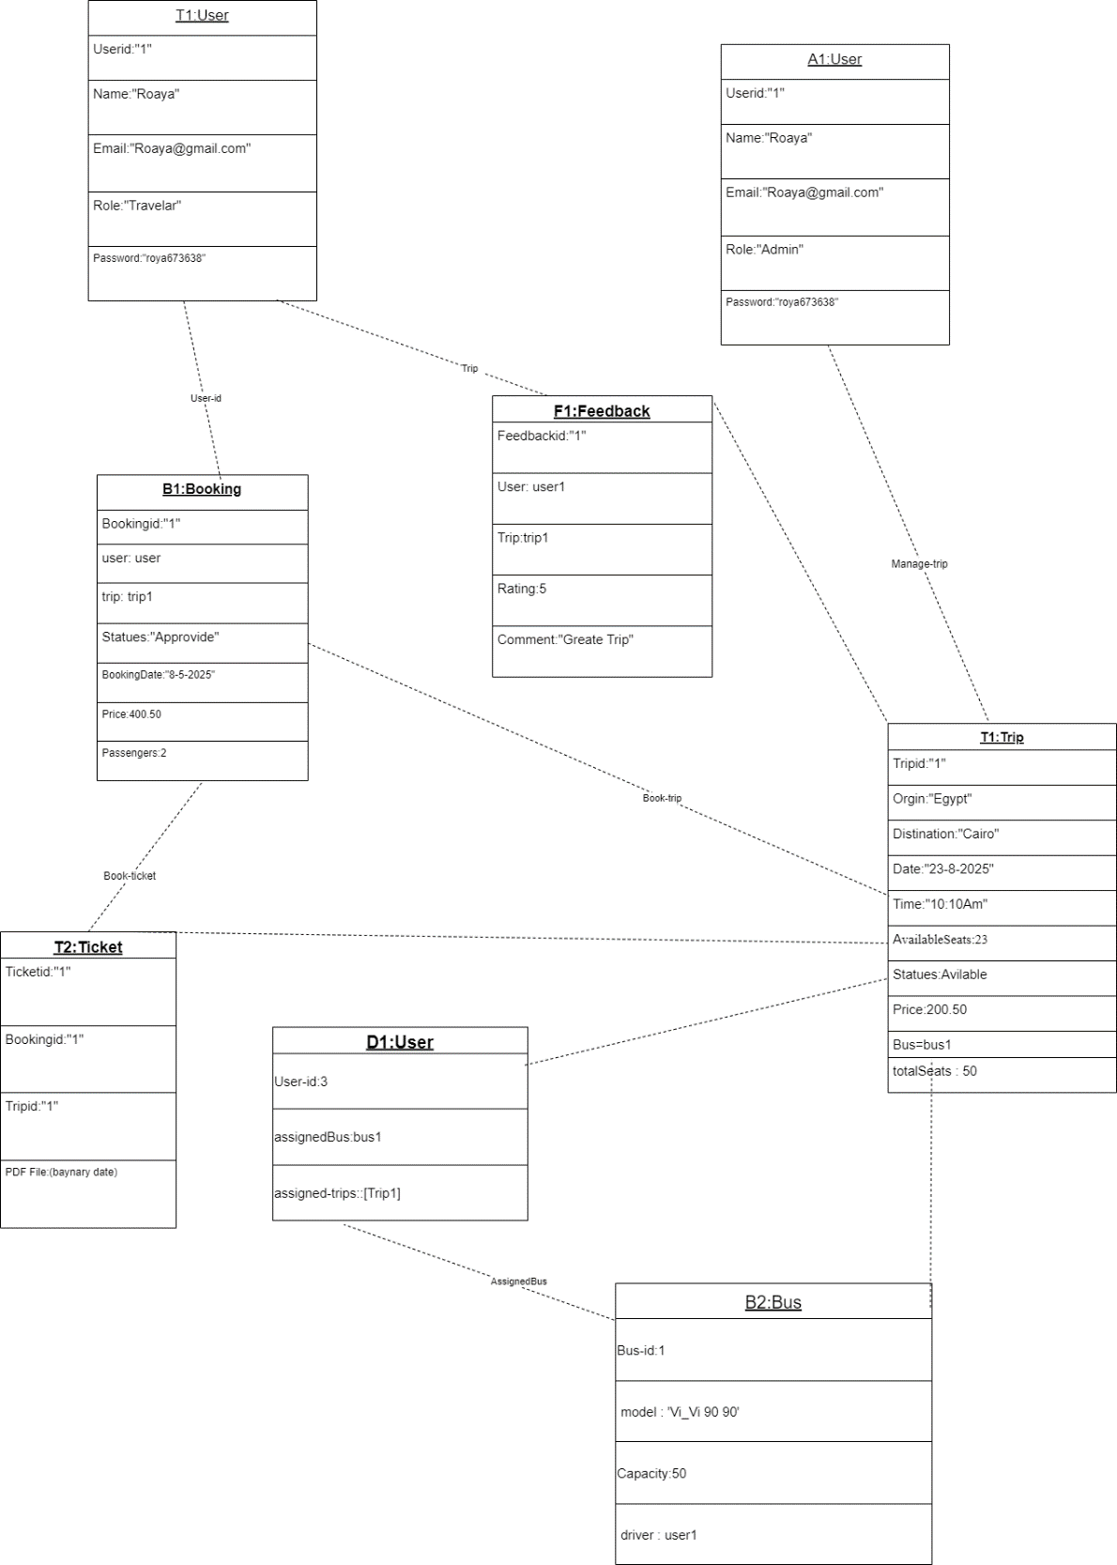

**3 - Sequence Diagram**

**----------------------------------------**

* Login / Register

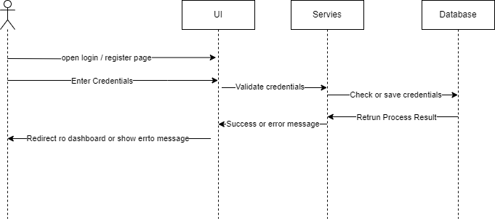

* Show Available Trips

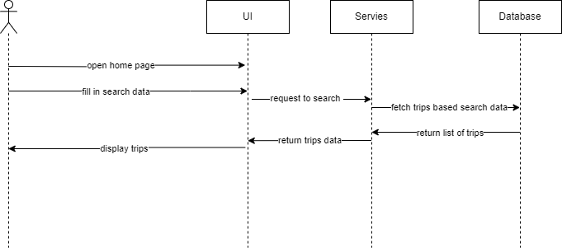

* **Booking Trip**

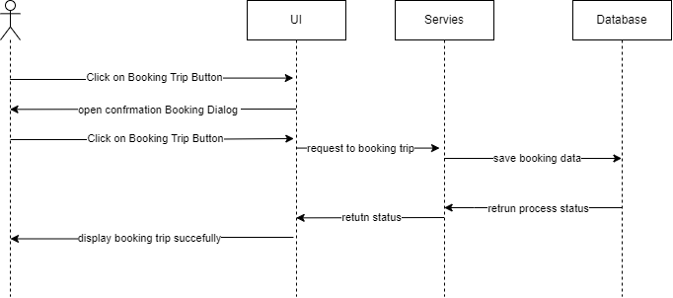

* Track Booking Status

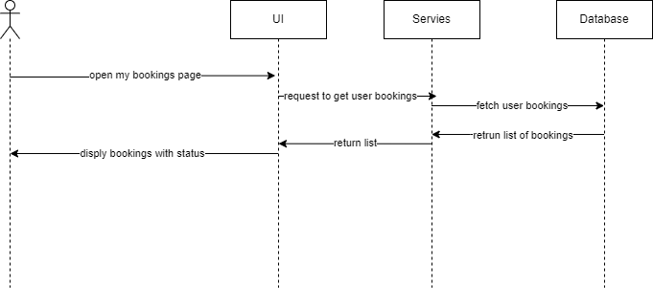

* Download Ticket

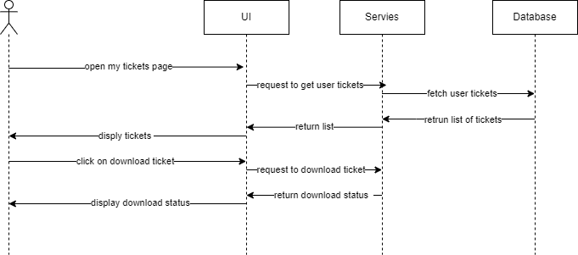

* Give Feedback

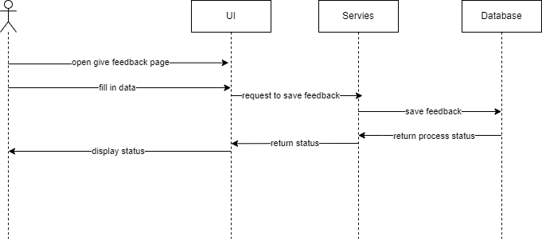

* View / Add Users

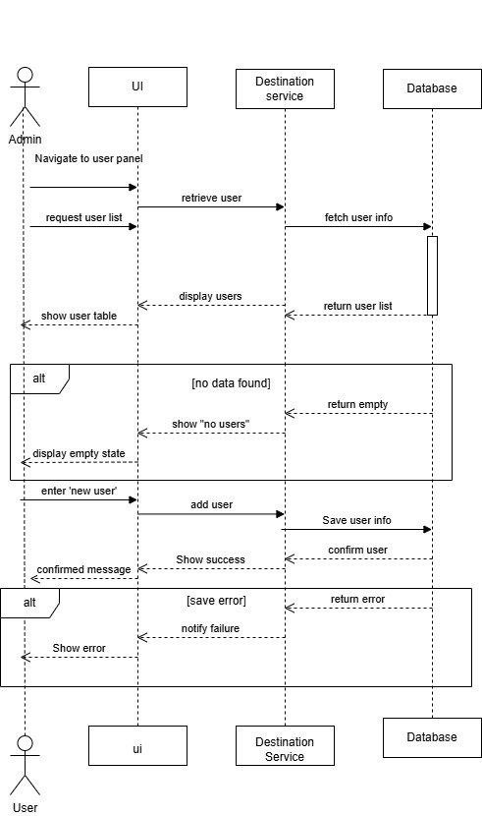

* Trip Management

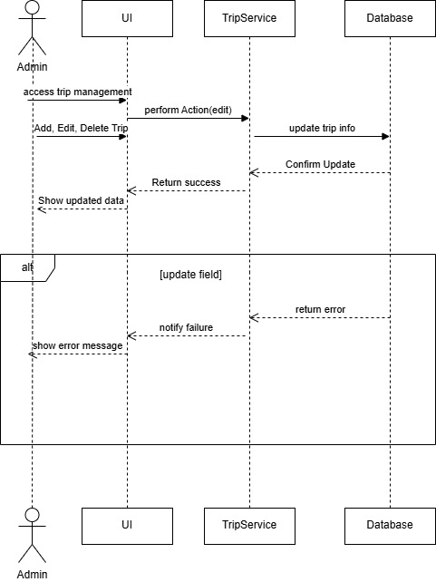

* Booking Request Process

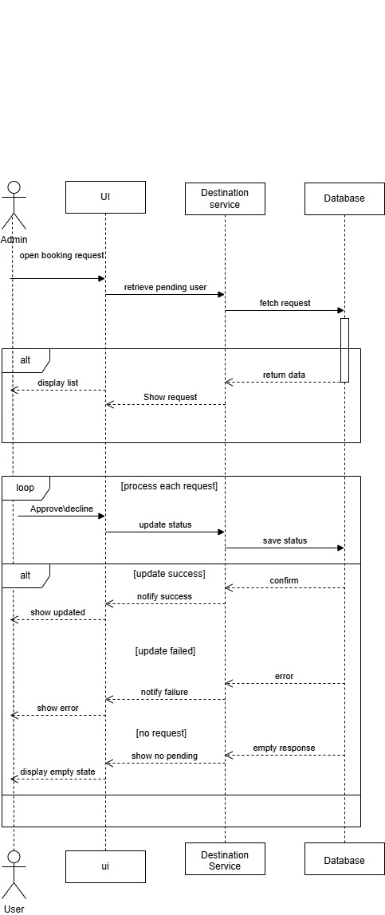

* Generate Ticket PDF

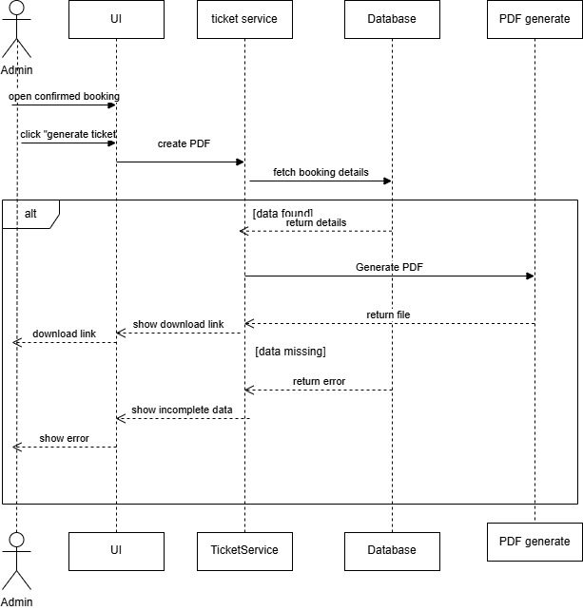

* Change Booking Status

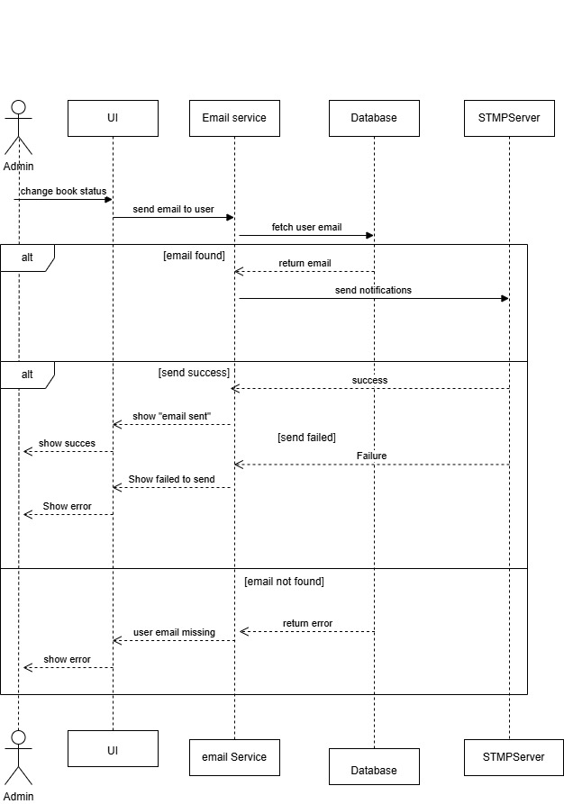

* View Feedback

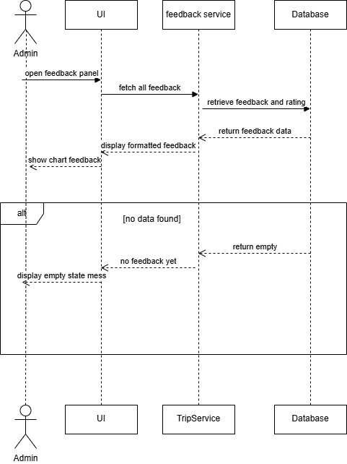

**4 - UI/UX Design**

**--------------------------------**

**Traveler Interface**

* **Sign in**

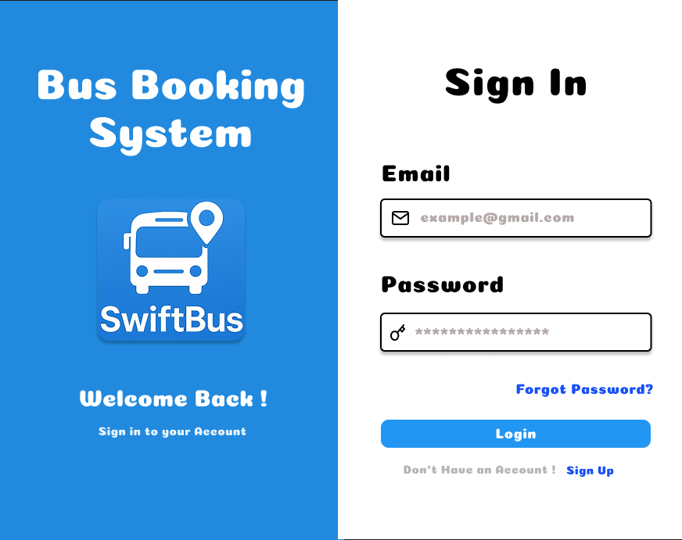

**Traveler Interface**

* **Sign Up**

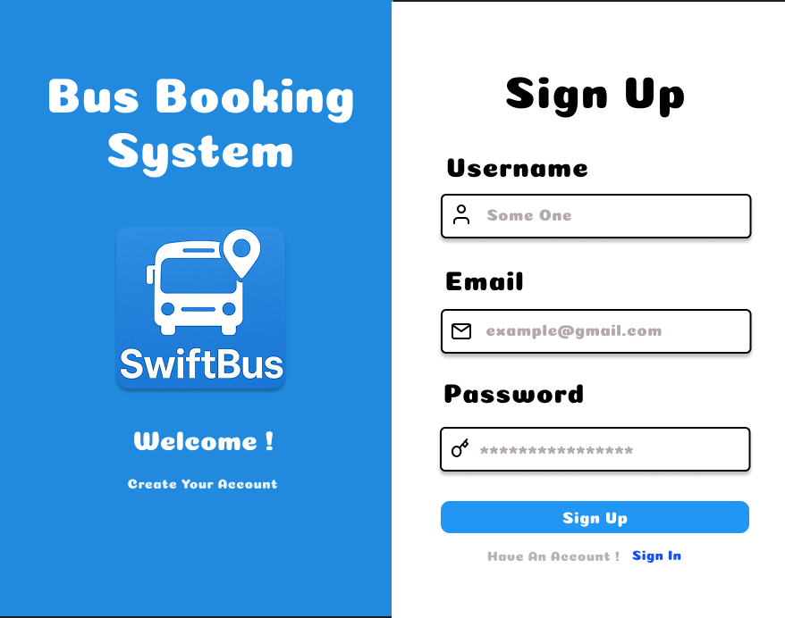

**Traveler Interface**

* **Reset Password**

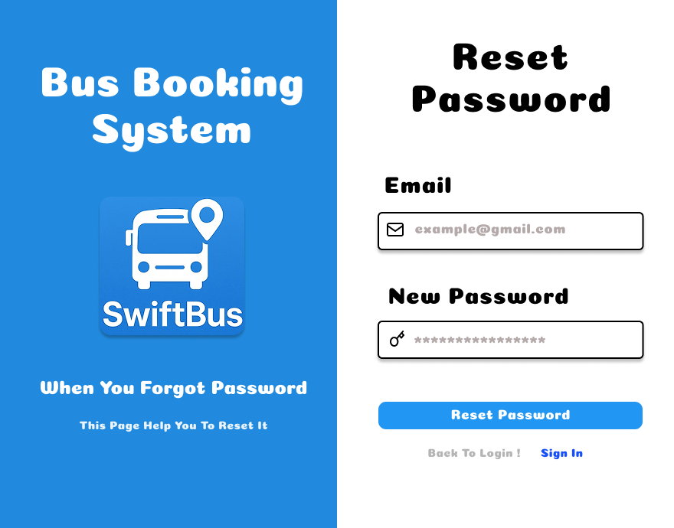

**Traveler Interface**

* **Home**

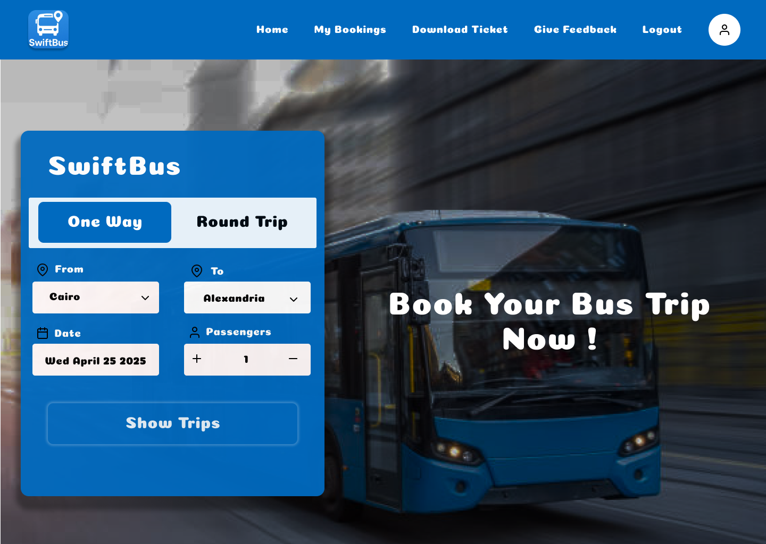

**Traveler Interface**

* **Available Trips**

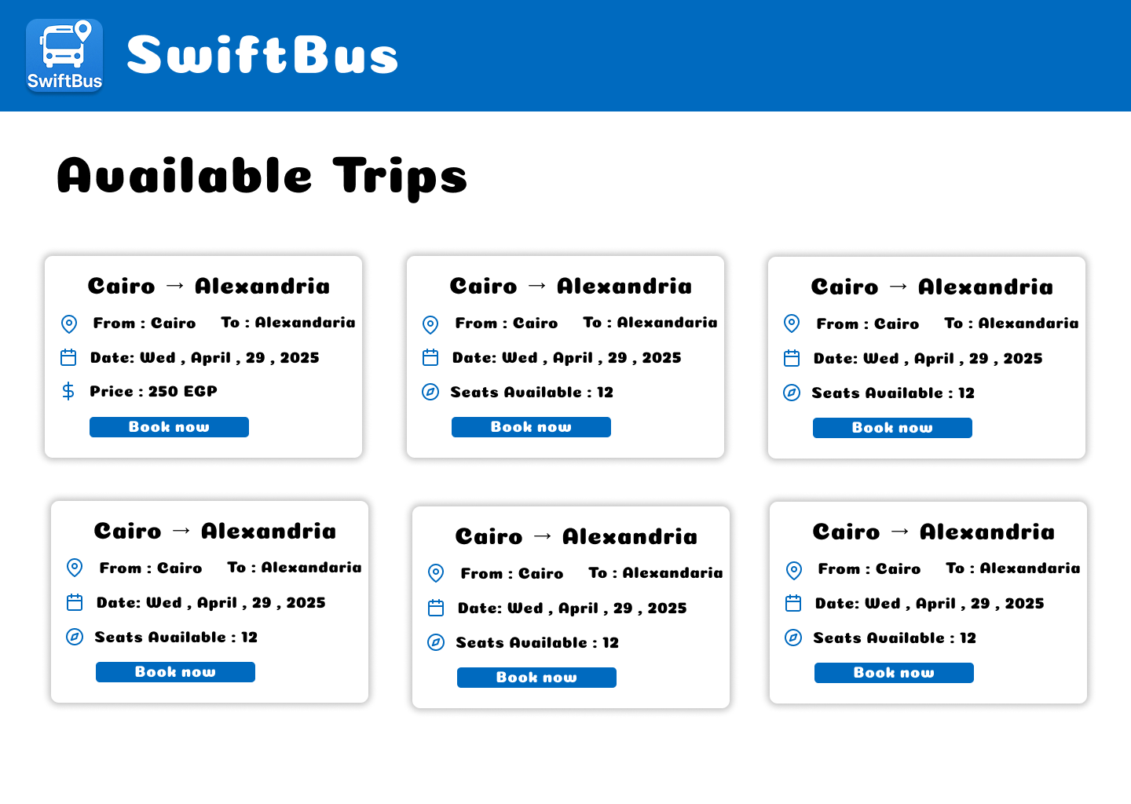

**Traveler Interface**

* **Payment Dialog**

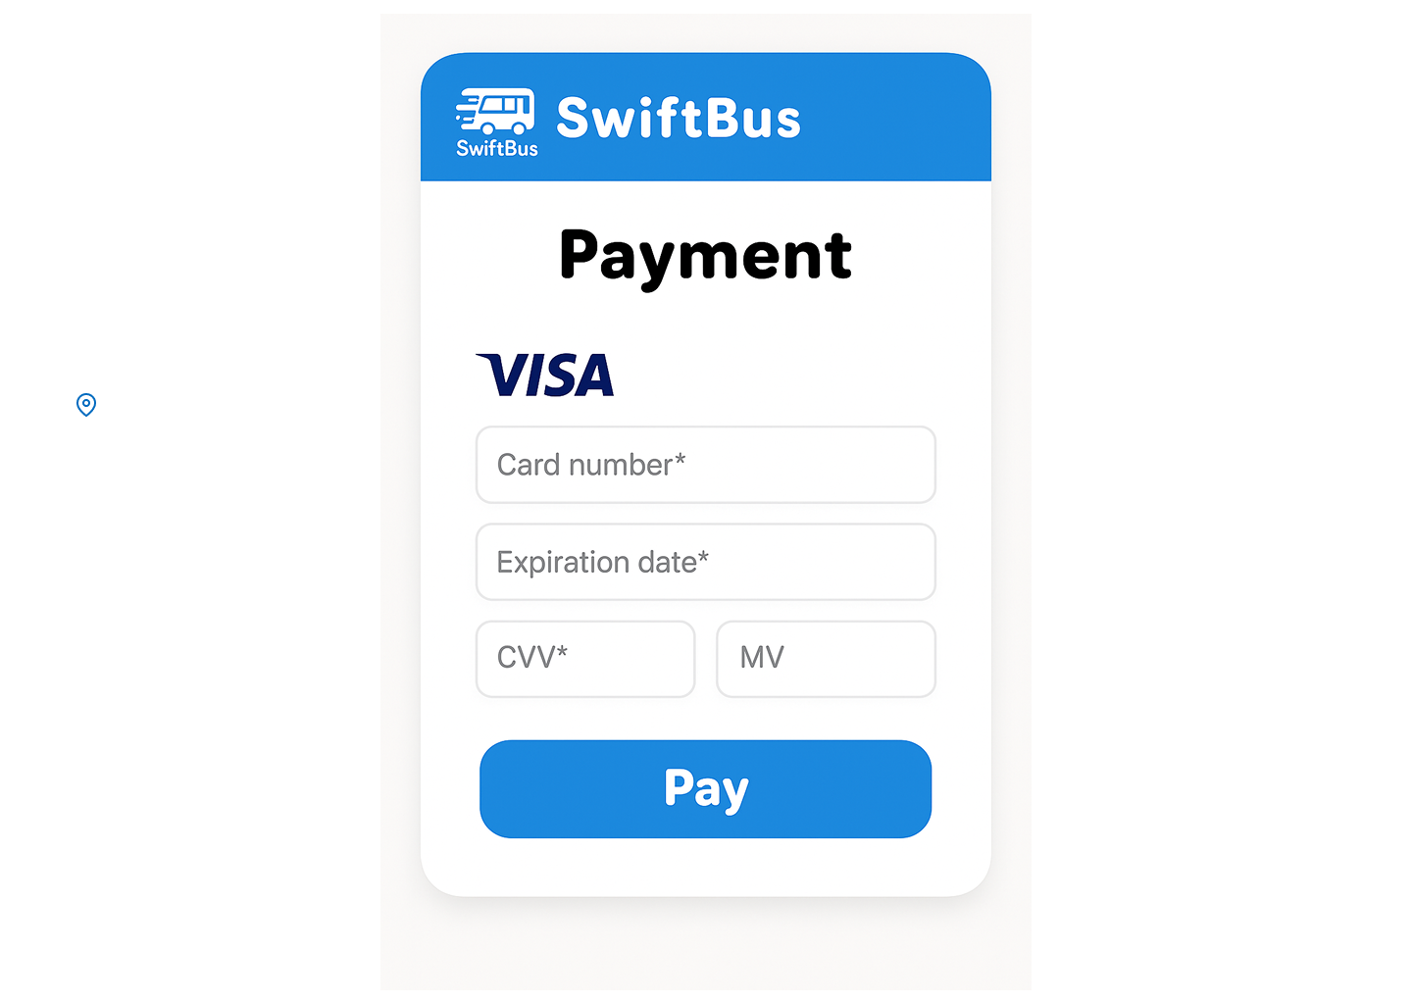

**Traveler Interface**

* **My Bookings**

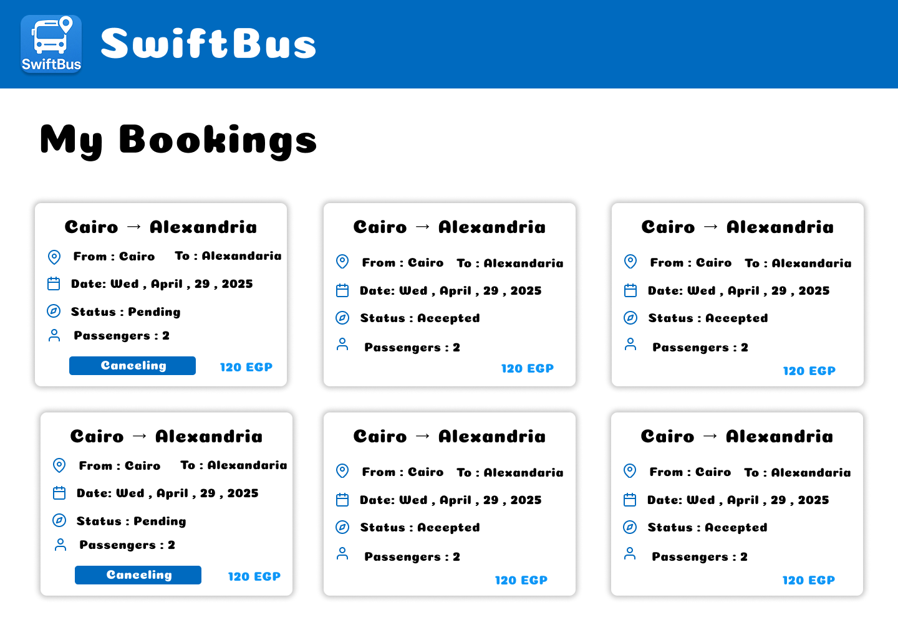

**Traveler Interface**

* **Download Tickets**

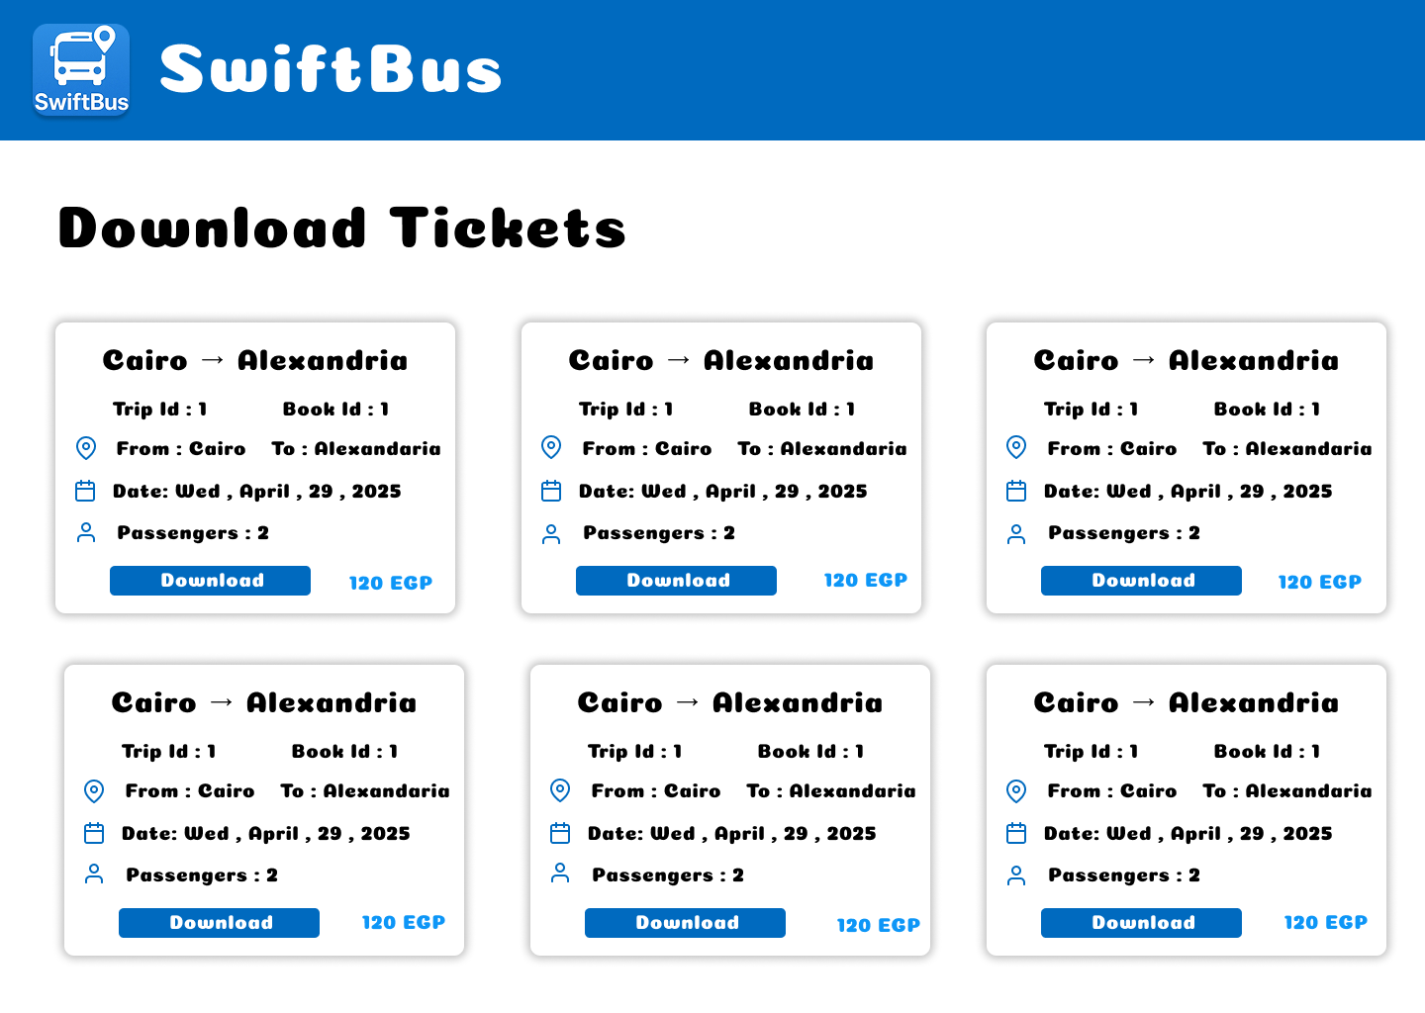

**Traveler Interface**

* **Give Feedback**

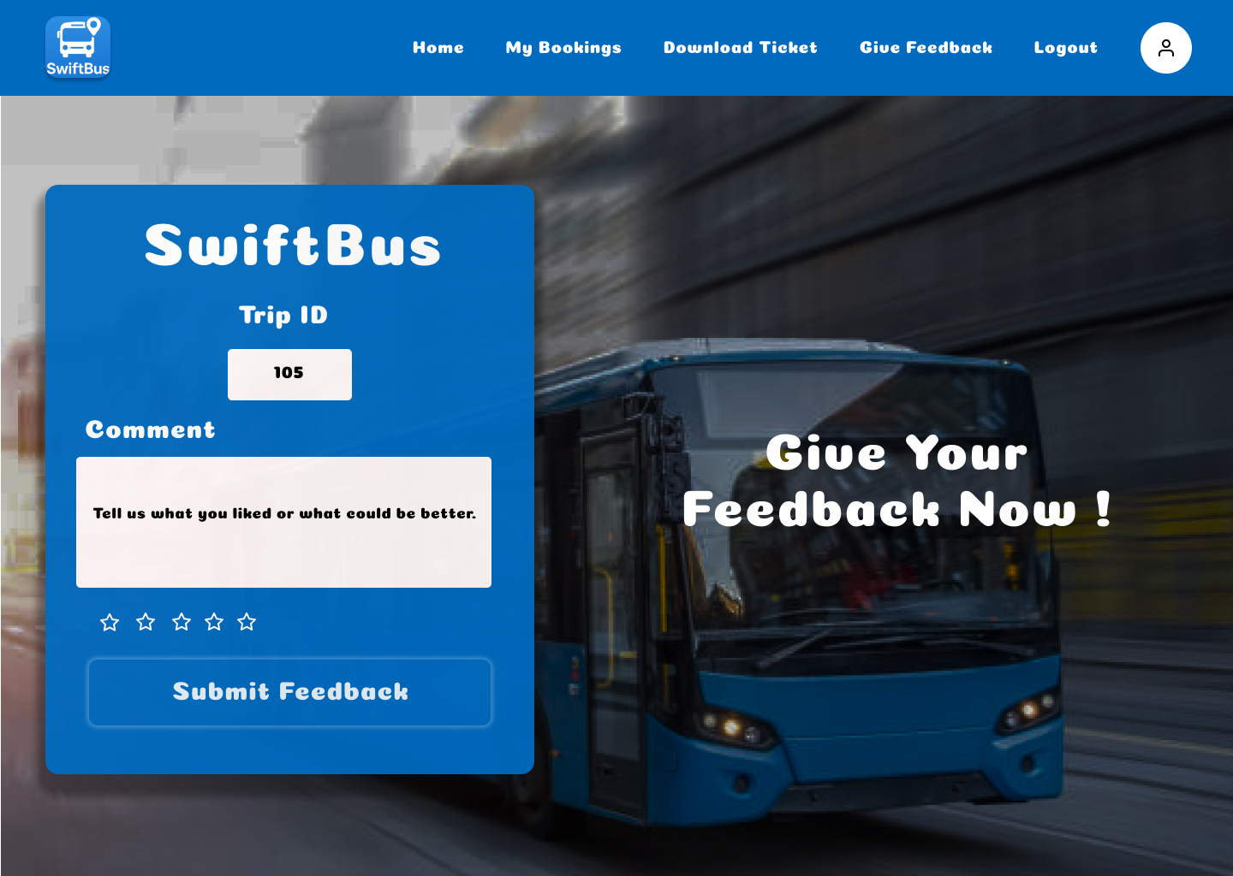

**Admin Interface**

* **Admin Dashboard**

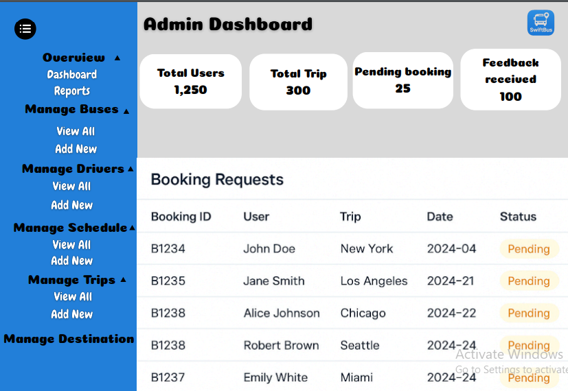

**Admin Interface**

* **Report Page**

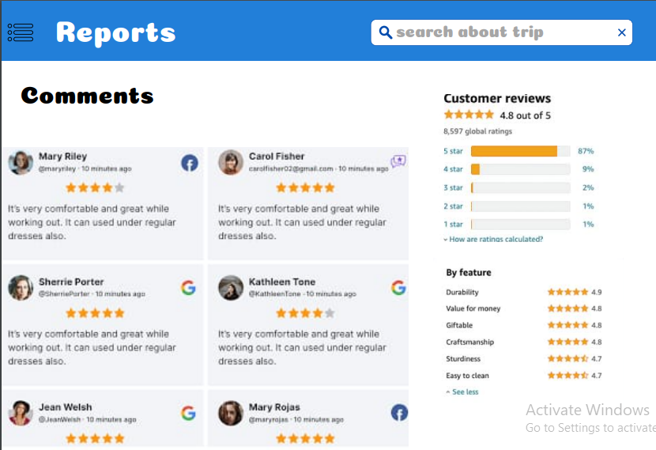

**Admin Interface**

* **Manage Buses (view all)**

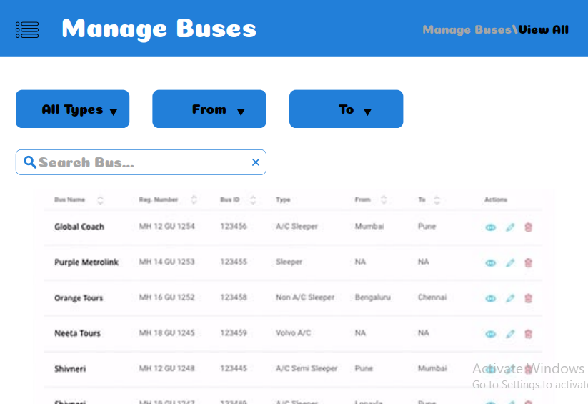

**Admin Interface**

* **Manage Buses (Add new)**

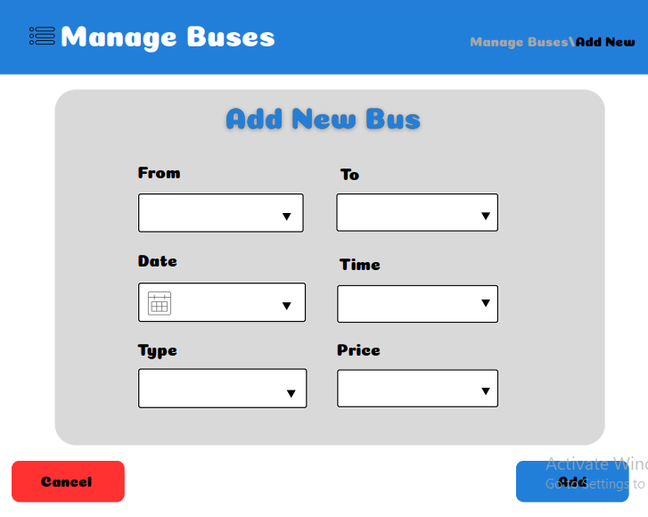

**Admin Interface**

* **Manage Drivers (view all)**

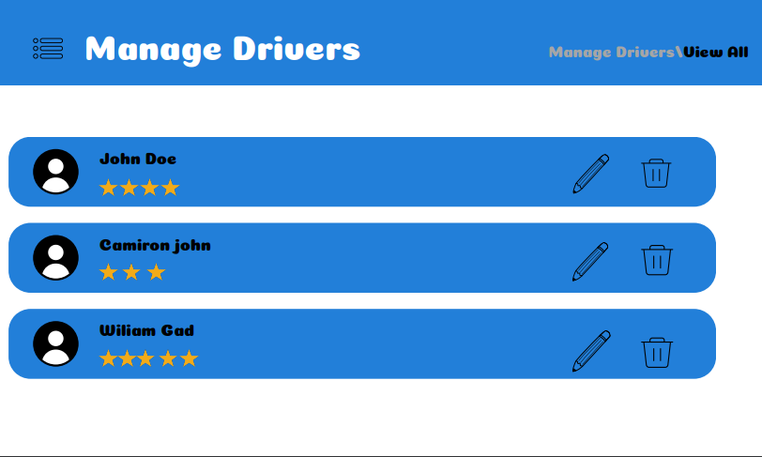

**Admin Interface**

* **Manage Drivers (add new)**

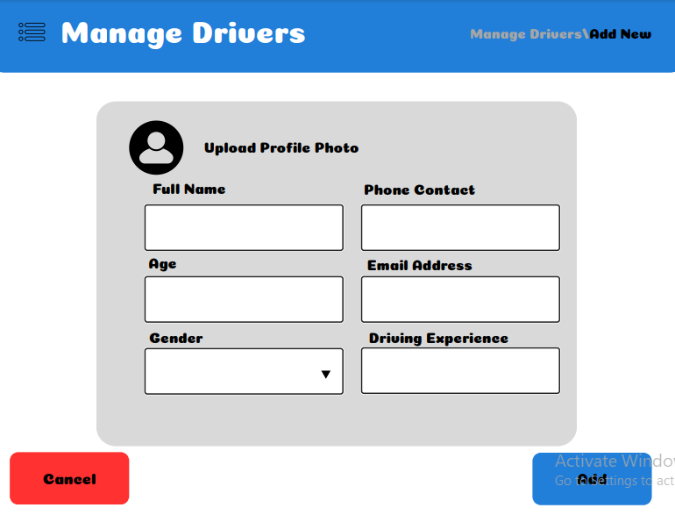

**Admin Interface**

* **Manage Drivers(edit info)**

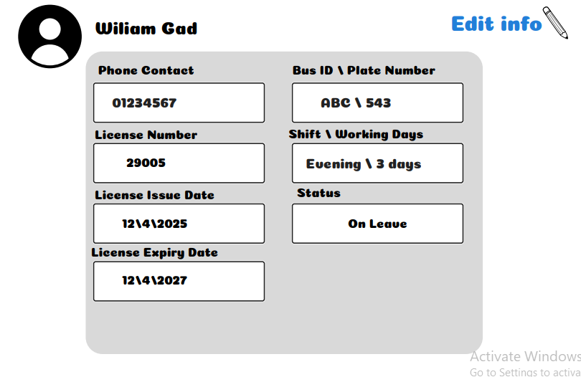

**Admin Interface**

* **Manage Schedule**

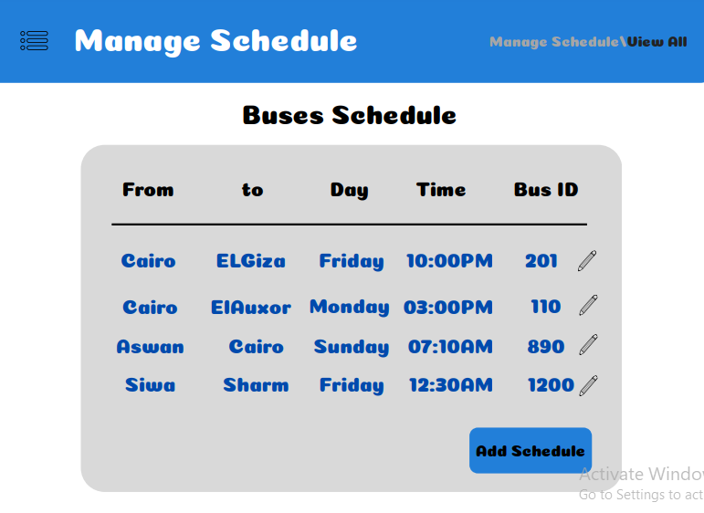

**Admin Interface**

* **Manage trips (view all)**

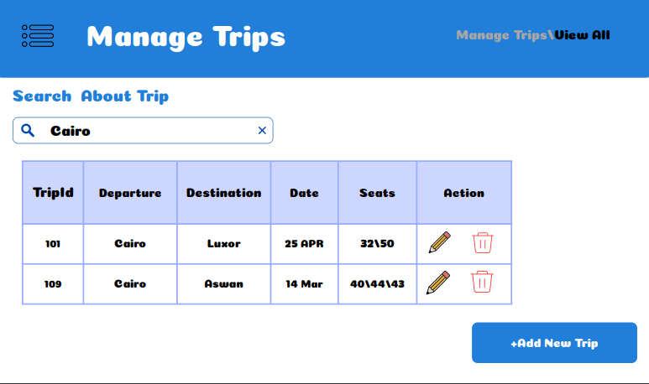

**Admin Interface**

* **Manage Trips (add new)**

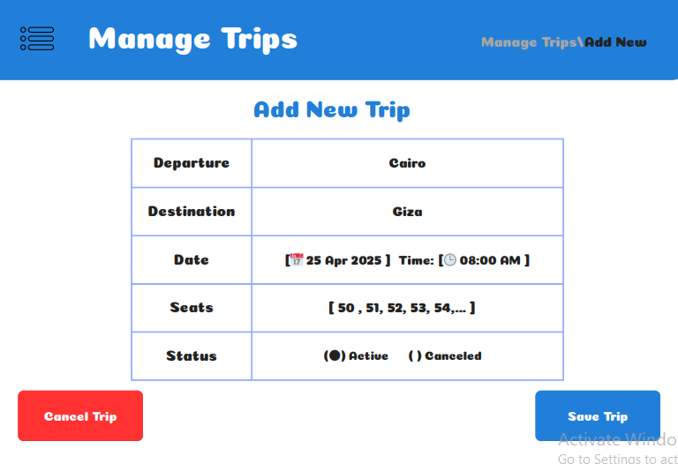

**Admin Interface**

* **Manage Destination**

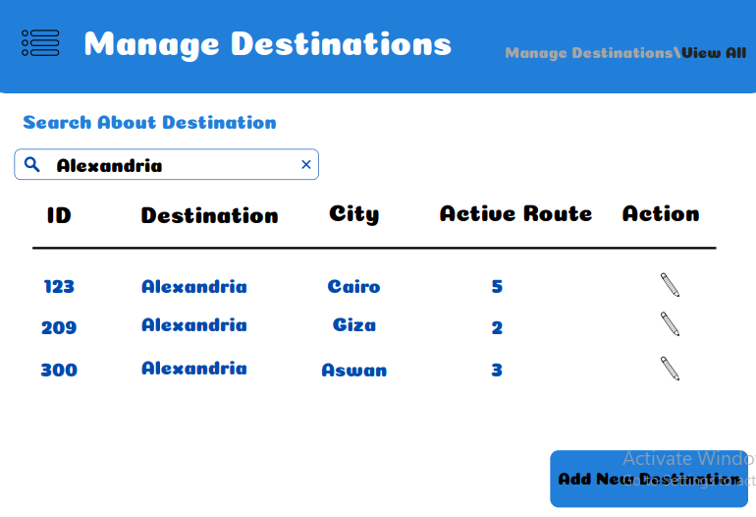

**Test For Application**

**Admin Pages**

**1.Admin Authentication and Role-Based Access.**

**---------------------------------------------------------------------------------------**

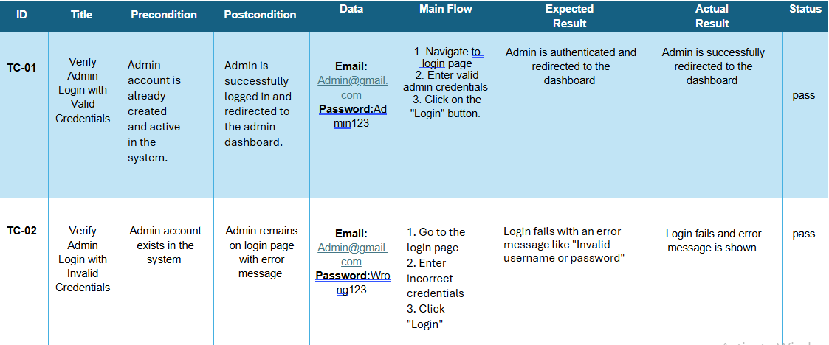

**2.Admin Dashboard Metrics Display Correct Data.**

**------------------------------------------------------------------------------------------**

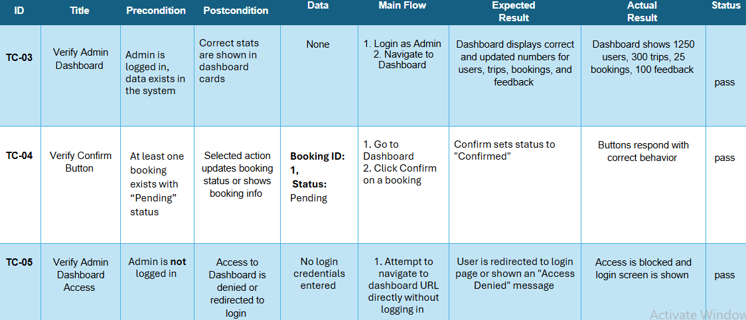

**3.** **View All Buses - Data Fetched Successfully**

**---------------------------------------------------------------------------------**

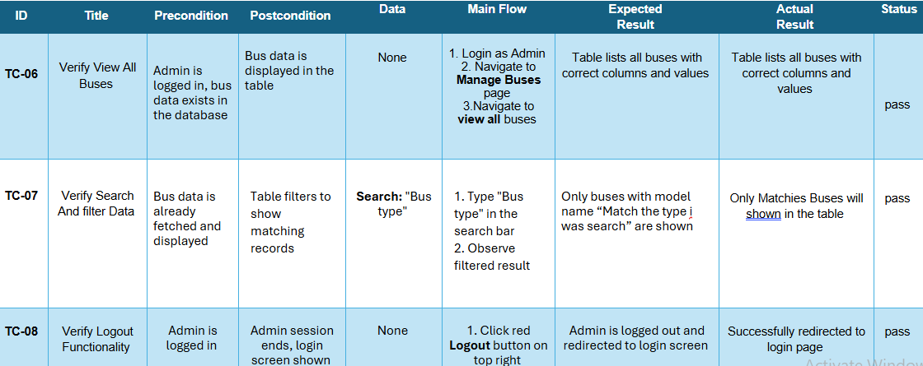

**4.** **Add New Bus - Successful Insertion-** **Cancel Operation**

**----------------------------------------------------------------------------------**

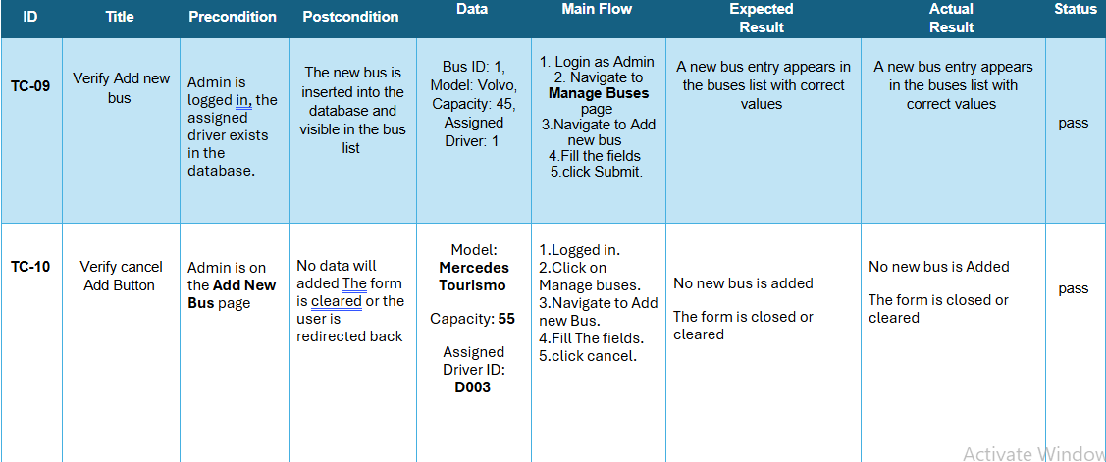

**5.** **View All users - Data Fetched Successfully**

**--------------------------------------------------------------------------------**

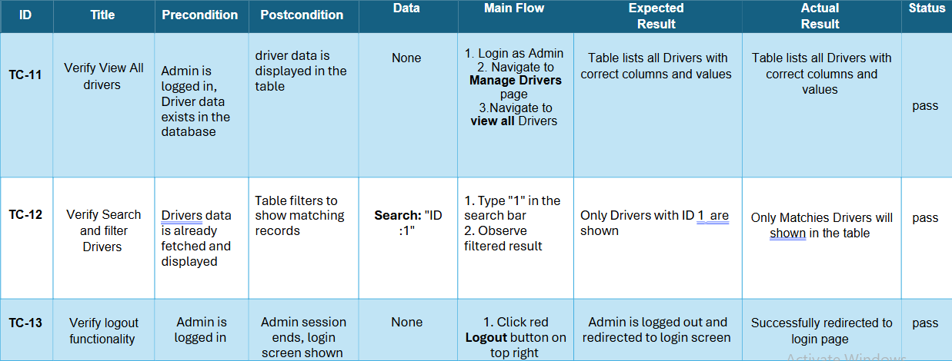

**6.** **Add new Driver - Successful Insertion-** **Cancel Operation**

**---------------------------------------------------------------------------------------**

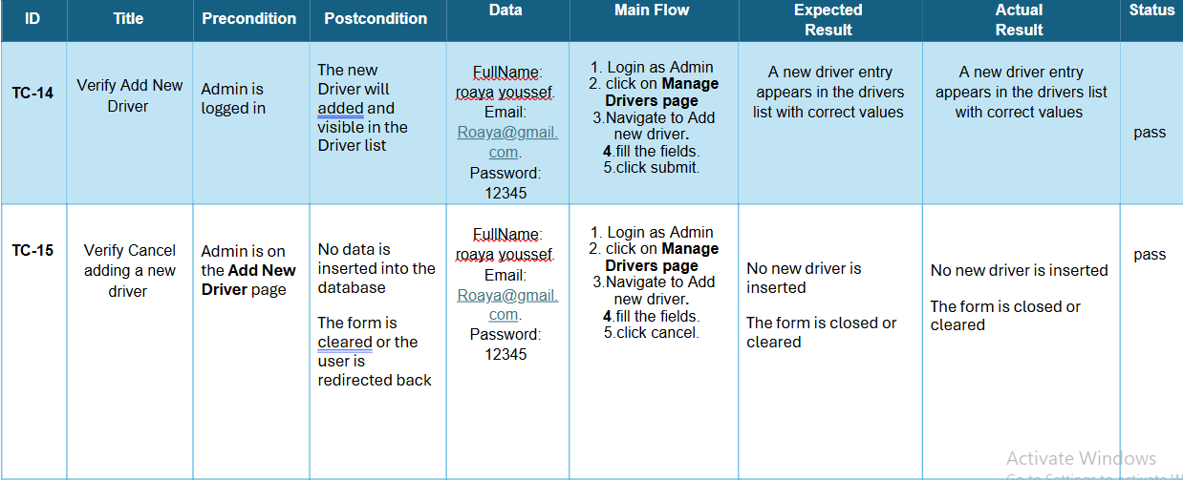

**7.** **View All Trips - Data Fetched Successfully**

**-------------------------------------------------------------------------------**

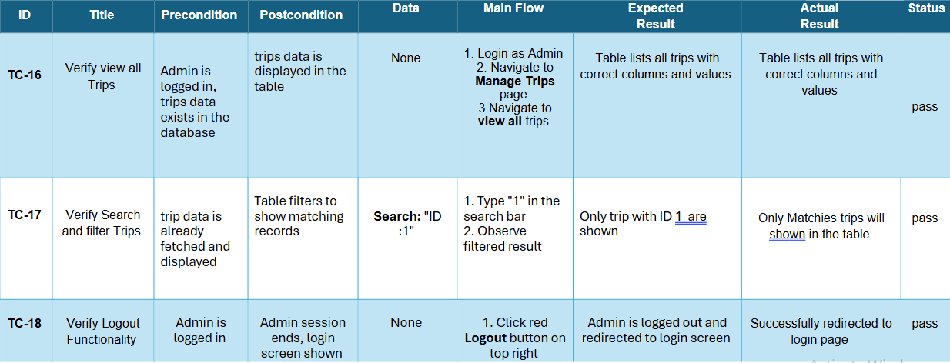

**8.** **Add new trip - Successful Insertion-** **Cancel Operation**

**-------------------------------------------------------------------------------------**

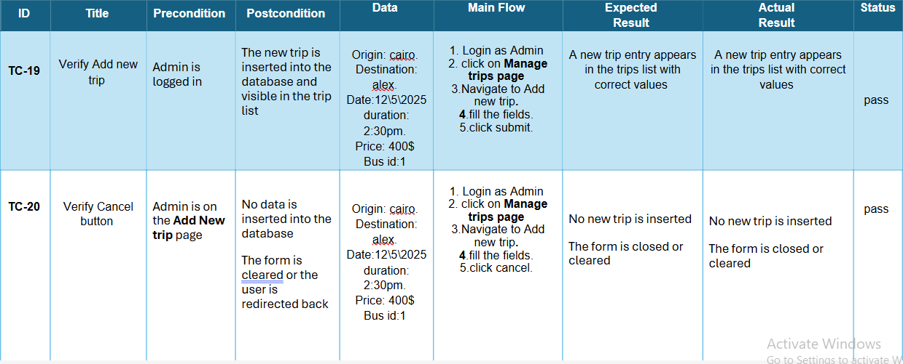

**9.** **View all Booking - Data Fetched Successfully-cancel button-keep it button**

**-----------------------------------------------------------------------------------------**

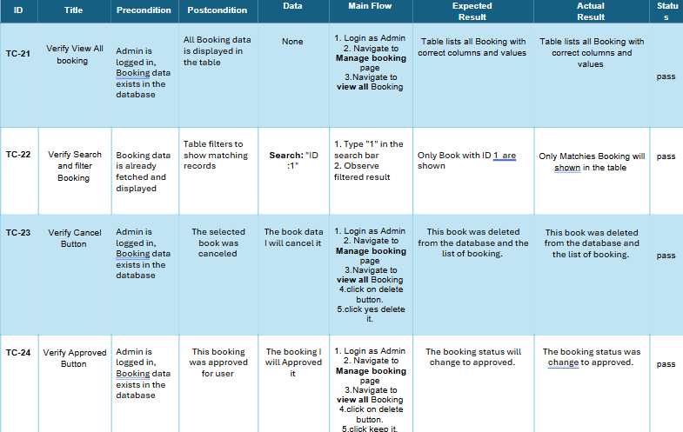

**User Pages**

1. login Authentication

-----------------------------------------------------

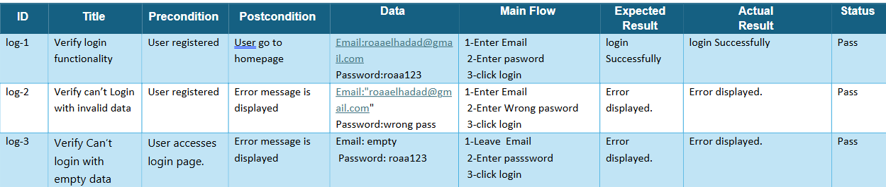

2. Sign Up Authentication

------------------------------------------------

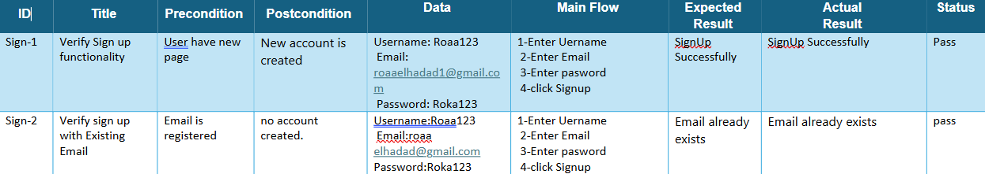

3.Reset Password Authentication

------------------------------------------------------------

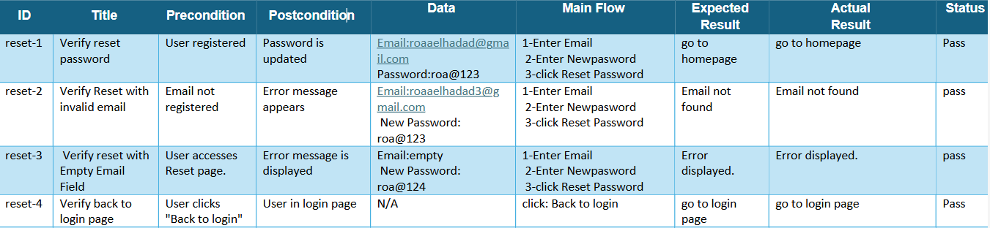

4.payment, Download ticket, view available trips

------------------------------------------------------------------------------------------

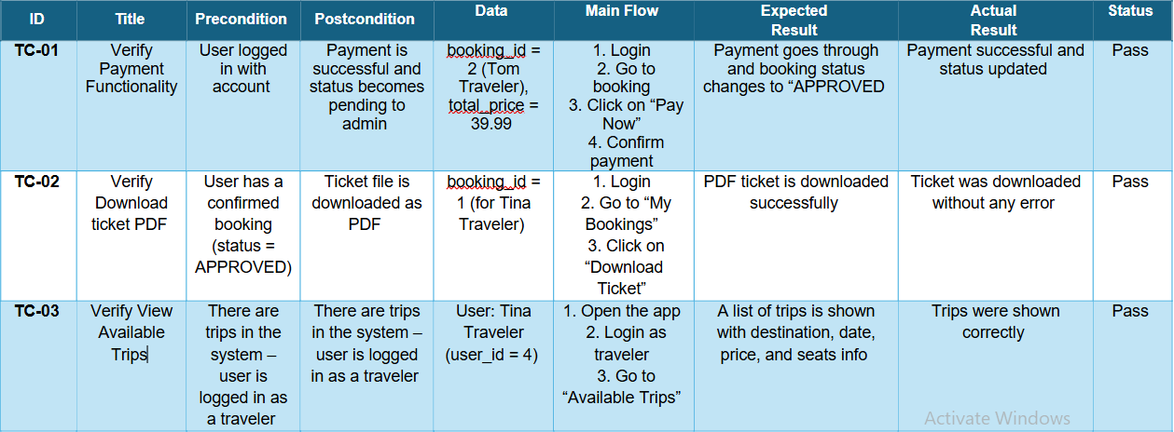

5.Home, My booking, Feedback pages

--------------------------------------------------------------------

End